Enter http://tracker.lee.k12.nc.us into address bar
Login to tracker using your Novell/Email username and password

May 15, 2014 1:25 PM
Tech Tracker 2
Username:
Password:

Click Add a Queue
You should see the following screen:
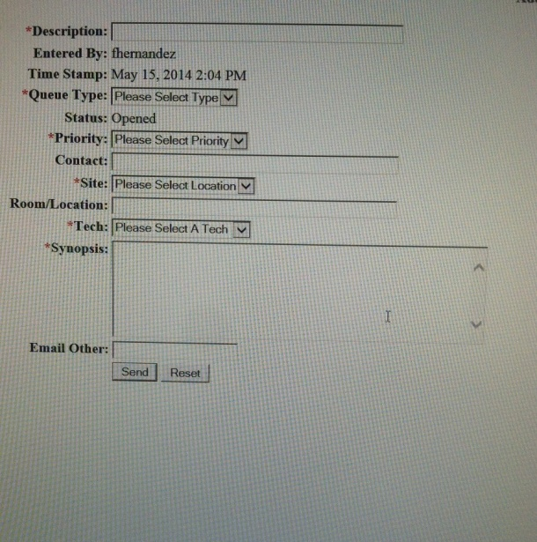

Now you can start typing what issues you or students are having
Below is an example:
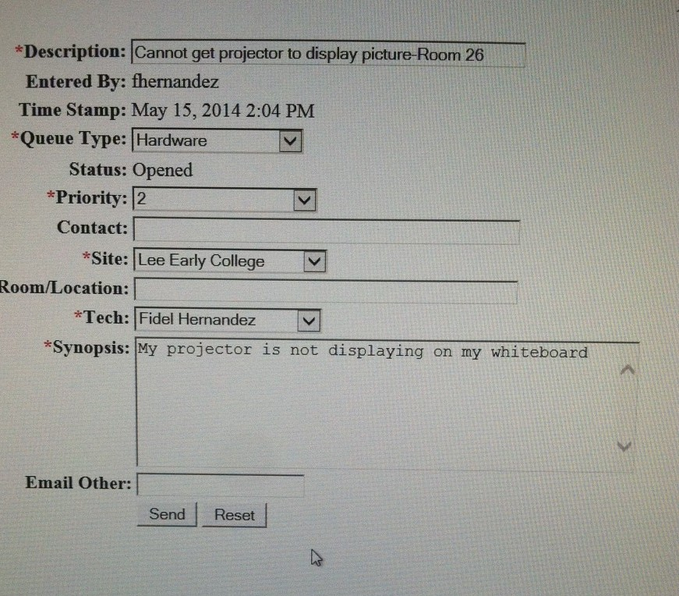
Definition of each line:
Description: Last name of teacher or student, problem and room number
Queue Type: Pick from the drop down list
Priority: Emergency should only be use for true emergency. Only use when the whole school is affected
Contact: Your name or the student’s name
Site: Lee Early College
Room/Location: room number where you are
Tech: Fidel Hernandez
Synopsis: Please fill this out with every detail. Tell me things that you have done to try and fix this issue.
Email: You can email yourself this tracker Queue. I automatically get one everytime somebody adds something.

